H.T No
Regulations:
A20

Sreenidhi Institute of Science and Technology
(An Autonomous Institution)
Code No:8BC02 Date: 18-Sept-2024 (AN)

B.Tech I-Year II- Semester External Examination, September-2024 (Supplementary)
ENGINEERING GRAPHICS(CIVIL, ECE, CSE, CS, AIML, DS and IOT)

Time: 3 Hours Max.Marks:70

Note: a) No additional answer sheets will be provided.
b) All sub-parts of a question must be answered at one place only, otherwise it will not be valued.
c) Missing data can be assumed suitably.
Bloom's Cognitive Levels of Learning (BCLL)

Remember | L1 | Apply | L3 | Evaluate | L5
Understand | L2 | Analyze | L4 | Create | L6

Part - A Max.Marks:20

Answer all QUESTIONS.

 |  | BCLL | CO(s) | Marks
1 | What is representative factor? | L1 | CO1 | [2M]
2 | Write the position of the object in all the four quadrants. | L1 | CO2 | [2M]
3 | Draw the projections of the cone, when its axis is perpendicular to V.P, base circle diameter 50mm and axis 60mm long. | L3 | CO3 | [2M]
4 | Draw the development of a square prism of base side 30mm and height 60mm. | L1 | CO4 | [2M]
5 | What is the difference between isometric projection and isometric view? | L2 | CO5 | [2M]
6 | Define line command and arc command? | L1 | CO6 | [2M]
7 | Find the R.F if 1cm = 50mm? | L3 | CO1 | [2M]
8 | A square lamina of side 25mm, is resting on one of its edge on H.P. draw its simple position. | L2 | CO3 | [2M]
9 | What is the difference between first angle and third angle projection? | L2 | CO5 | [2M]
10 | Draw the isometric view of a hexagonal plane parallel to the V.P of side 30mm. | L1 | CO6 | [2M]

Part – B Max.Marks:50
ANSWER ANY FIVE QUESTIONS. EACH QUESTION CARRIES 10 MARKS.

 |  |  | BCLL | CO(s) | Marks
11. |  | Draw a hyperbola when the distance between its focus and directrix is 50mm and eccentricity is 3/2. | L3 | CO1 | [10M]
12. |  | Draw the projections of the following points on the same ground line, keeping the projectors 20mm apart.  (a) Point C in the VP and 40mm above HP.  (b) Point D 25mm below the HP and 25mm behind the VP.  (c) Point E 15mm above the HP and 50mm behind the VP.  (d) Point F 40mm below the HP and 25mm in front of the VP.  A point P is 20mm below HP and lies in the third quadrant. Its shortest distance from xy is 40mm. Draw its projections | L4 | CO2 | [10M]
13. |  | A cone of base 60mm diameter and height 70mm lies with its base inclined at 30⁰ to H.P. draw its projections. | L3 | CO3 | [10M]
14. |  | A cone of base circle diameter 60mm and height 75mm long is resting on the ground on its generator. It is cut by a section plane parallel to the generator which is resting, passing through mid-point of the axis. Draw development of the remaining solid. | L4 | CO4 | [10M]
15. |  | Draw the isometric view of a hexagonal prism resting on its face on the ground. Base side = 30mm and height of the solid = 60mm. | L3 | CO5 | [10M]
16. |  | Draw the front view, top view and side view of the below figure. All dimensions are in ‘mm’.  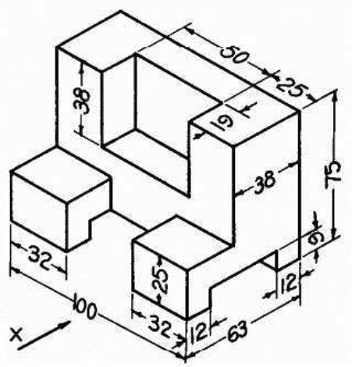 | L4 | CO6 | [10M]
17. |  | A circle of 50mm diameter rolls along a straight line without slipping. Draw the curve traced out by a point P on the circumference, for one complete revolution of the circle. Name the curve. | L4 | CO1 | [10M]
18. |  | What are the applications of AutoCAD? How can you modify an object's properties in AutoCAD? | L2 | CO4 | [10M]
-- 00 -- 00 –

